**LOTO Standard Also on OSHA's Update List**

Recently we featured that OSHA was soliciting information on powered industrial vehicles to determine the need for an updated standard.  Now OSHA is soliciting information on the lockout-tagout (LOTO) standard.  The current LOTO standard was published in 1989.

The focus of OSHA's efforts with LOTO centers on control circuit devices.  The LOTO standard requires energy-isolating devices to be used to control energy during servicing and maintenance of machines and equipment.  In the current standard, control circuit devices cannot be used for this purpose.  However, OSHA says it "recognizes recent technological advances may have improved the safety of control circuit-type devices."

Since 2016, OSHA has granted variances in compliance to several companies who have been able to prove that the control circuit devices they were using could be a safe alternative.  During an evaluation of a recent variance request, OSHA decided that the time had come and the potential technology was available to consider if there was a basis to allow these devices in certain circumstances. Also, their own research has shown that these devices aren't typically used in short servicing tasks of a machine and don't require an extensive disassembly of the machine or entrance into it. As a result, OSHA wants feedback from the public and industry about this.

OSHA is requesting information on:

* How employers have been using control circuit devices
* Information about the types of circuitry and safety procedures being used;
* Limitations of their use, to determine under what other conditions control circuit-type devices could be used safely;
* Use and limitations of using industry consensus standards for LOTO such as ANSI/ASSPP Z244.1;
* How the evolution of robotics technology such as collaborative robotics, robotics that move freely, or robotic devices that can be worn by workers has affected risks of worker exposure to hazardous energy;
* The anticipated economic benefits, impacts, and other offsets that would occur if the standards were updated, such as benefits to productivity or reduction of injuries vs. costs of new equipment, servicing, or need for new training.

LOTO and electrical-related issues are found to be among OSHA’s Top 10 violations each year.  The agency is accepting comments electronically until August 18, 2019 at [regulations.gov](https://www.regulations.gov/) and from there, OSHA will be making a determination of what actions, if any, needs to be taken.  More information [can be found here](https://s3.amazonaws.com/public-inspection.federalregister.gov/2019-10247.pdf).

More and more Lithium ion batteries are being used in products today and just like any material, if we understand how to use it safely, it should not pose any problems. Many times however manufacturers do not do a good job of educating people of the risks with using certain materials, especially when it comes to consumer products. This can be a problem when we go from using items like laptops that commonly have 6 lithium cells, to 7000 lithium ion cells to run an electric car. The risk has changed significantly when it comes to the fire this may cause. If an EV catches on fire in your garage, you most likely do not have a way to deal with a car sized 3632° F fire.

Should I really worry about my battery catching on fire? If your battery stays intact, and does not allow moisture to get inside, or as long as there is not an issue with overcharging where the temperature runs away, you should be fine. The issue is that lithium and water don’t like each other. In fact, in its pure form, water causes lithium to react, sometimes violently, creating sparks and lots of heat, as well as hydrogen gas. Lithium Ion batters are a little different than the pure form of lithium, in that they are filled with a lithium compound, and not pure lithium. Because of this, the material in many batteries are not quite as active with water. But when you have 7000 cells in one place, if one catches on fire, a chain reaction can occur that you cannot control. Also fighting that fire with water, may not be the best solution when water can cause it to react more.

This can be the same for industry. Lithium ion batteries are being used in everything from pumps and instruments, to cars and equipment, computer servers, and so many more products. Even your wireless mouse may have lithium ion batteries. If you just throw that away in the trash, not only are you potentially violating waste regulations, DOT shipping regulations, and you may also be creating a fire hazard for the waste removal truck, and the landfill that it goes to. Recently the issue with shipping lithium batteries for recycle or waste has gotten out of hand.

The Pipeline Hazardous Materials and Safety Administration (PHMSA), which is the HazMat division of the DOT, issued a safety advisory on the dangers to help people out. If you would like to educate yourself and others at your company, you can go here to read it yourself ([link](https://www.phmsa.dot.gov/sites/phmsa.dot.gov/files/2022-05/Final-05-16-Lithium-Battery-Recycling-Safety-Advisory.pdf)). iSi also teaches the proper way to recycle, dispose, and ship lithium batteries, and you can sing up for classes here….

**Sometimes You Really Need to Listen to the Voices in Your Head**

At iSi, the office and marketing/sales teams get involved in safety too, and one of the things we do is we each get a week to share something about safety that has affected us personally. This is what I plan to share this month during my turn, and I hope you can take something away from it, especially as we head into National Safety Month this month. – Tami

###

Usually when someone talks about the voices in their head, it’s kind of a joke, or played off as a negative thing. However, sometimes those voices can tell you good things that you actually need to listen to. There was one important time I wish I had listened to the voices that were trying to help keep me safe, but didn’t.

In late June of 2001, 20 years ago this month, my sister-friend and I were seriously scalded in a kitchen accident. My friend used to think homemade was the way to go. Six kids later she thinks a little differently, but back then that’s the way it was. She was canning green beans from her garden and she had one of the old-time pressure cookers from the 70s. She hadn’t used it much, and I certainly didn’t know anything about it.

One night when I was visiting, she was wanting to get the beans canned. Her husband usually took care of the pressure cooker part but he was gone that night. She had seen him do it, so she decided she would do it herself. When it was time to take the jars out, she couldn’t get the lid of the cooker off. Earlier that evening, the lid was really hard to get on, and so it made sense that it would be hard to get it off. She enlisted my help. I’m a helper…sure I’ll help. We stood over the stove and started trying to muscle the lid off, and it wasn’t moving.

We paused for a moment. In that pause, later we both found out that a voice in our head was saying to each of us “Wait a minute, maybe this isn’t a good idea.” However, we are both get ‘er done types and there were a lot of other things to get done that night, so we proceeded. What we proceeded into was pressurized scalding water going everywhere. We had missed a step – depressurizing the cooker.

The water flew everywhere. Scalding water covered my head, face, arms, hands, chest, stomach and upper thighs. She got it all over her arms, legs and feet. After being temporarily blinded, I ran to the bathroom sink for the cool water, and she went to the kitchen sink. Besides the extreme pain, I knew it was bad when I looked in the mirror and saw a huge piece of skin on my nose falling off and my face beginning to swell. I found out later that the boiled water remaining on my clothes was continuing to burn me. I kept them on until I was convinced to strip down in the ambulance. Well, not until I made them shut the door, and make my cop friend who was working that night, go away.

I ended up spending the night in the burn unit with second degree burns over 30% of my body and my friend had second and third degree burns. The nurses in the emergency room had a real good time with me after learning I worked for a safety consulting company. They made all the medical personnel who came in ask me where I worked so I could relay the irony of the situation.

It was a long, painful July for the both of us and it took us about a month for full recovery. We both still have scars, especially on our arms. I tell her it’s like a tattoo to remind us of what we went through and what we should/shouldn’t do. We are extremely fortunate and blessed it didn’t do any other long lasting scarring damage besides that.

**If we would have listened to those voices in our heads, we could’ve stopped this accident from happening. Please relay to your teams that it is OK to stop and listen to those voices in your head when something does not seem right. It’s ok to take a moment to rethink something before you do it. Nothing is too important or needs to be completed so quickly that you can’t take a moment to rethink it, especially when it comes to your safety.**

Some safety lessons I took away from this ordeal…

1. It’s OK to listen to the voices when it comes to your safety.
2. If you’re scalded, remove the clothing that has the hot water on it to prevent continual burning. A lot of my most painful injuries was a result of this.
3. Scalding burns larger than 3 inches or that cover more than one area of your body need medical attention.
4. Run cool or lukewarm water (not cold) over the area but don’t submerge yourself in it or you could lose body heat.
5. If you’re going to use a pressure cooker, buy the ones with the best safety features and won’t let you take the lid off until you depressurize it. My friend did bravely “get back up on the horse” and used that old cooker again, but more safely. I still refuse to be in the same room with it.
6. Always be familiar with the proper procedures for using something – don’t rely on only doing it by sight or watching someone else – you may miss something very important.

What’s your safety story? Do you use personal safety stories in your safety programs? How is it working? Let us know!

**What Are Lab Packs and How Could Your Facility Use Them?**

By Guest Contributor, Casey Moore of iSi’s Southeast Office

I’ve never been a fan of “spring” cleaning, but it is a necessary part of good housekeeping around the home, or at your facility. When was the last time your facility did a “spring cleaning” walkthrough to see if there are any materials around your workplace that are expired, or you don’t need? Flammable cabinets, chemical storage, research/QC labs and maintenance shops are likely places these items accumulate.

**What is a Lab Pack?**

Since most of the items in these locations are likely to be in smaller containers, they aren’t treated like regular waste streams. Lab packs are a practical solution. Lab packs are consolidation packaging of “like” materials from the smaller containers into larger containers to satisfy proper DOT shipping and EPA RCRA hazardous waste management.

The lab pack was designed for managing expired materials in labs, however, it’s something that can be used for any facility that needs to do a cleanout of smaller containers usually less than 10 gallons each.

**What Items Are Candidates for a Lab Pack?**

Look for jars, jugs, vials and cans of hazardous materials, including chemicals, solvents, paints, thinners, acids, cleaners, strippers, inks and more. These are typically out of date, off-specification, partially used, and no longer needed.

**Who Does Lab Packing?**

There are strict regulations on who is authorized and qualified to do lab packing. This is because of the need to determine which containers can be put together and which ones may cause harmful reactions with each other. Typically, hazardous waste carriers provide this service.

**How is Lab Packing Accomplished?**

First, items are segregated, that is, sorted, for combining into one larger container. Items are segregated by:

* Hazard class – most common are flammables, corrosives, and toxics
* Type of material – liquids, solids, etc.
* Compatibility

“Paperpack” is the term used to show the segregation by container. An initial inventory list is converted into lab pack inventory sheets (what goes into each container). This is what waste companies use to create approval numbers for compliance under RCRA. It is also how they establish price. Pricing is based on disposal, transportation and labor associated with packaging.

Packaging is accomplished by:

* Putting the segregated materials into their respective larger containers;
* Filling with a packing material (vermiculite is most common) to create stability and containment while shipping;
* Vermiculite will be in the base and surrounding each of the internal containers; and,
* The smaller containers are placed into the larger container vertically, so the label with the double arrows pointing up is on the outer packaging.

**RCRA Regulation Implications**

A lab pack counts towards your waste generation status if you’re a Very Small Quantity Generator (VSQG), or a Small Quantity Generator (SQG), so be mindful of the amount of hazardous waste generated in the process.

For states that have already adopted the Generator Improvements Rule, this is a good use of the episodic event, and would not count against your generator status.

**Social Media Post**

**Blog, Facebook, Linked In, Twitter, Google+(KS), Sidebar Item in Training Email**

Change Needed to Kansas Facility SPCC Plans

KDHE has a new telephone number to use when you need to report a spill. This may affect your Spill Prevention Control and Countermeasure, or SPCC, Plans and therefore you’ll need to update them. The new number is 785-291-3333. Updated Spill Notification procedures can be found at [*http://www.kdheks.gov/spill/download/KS_Spill_Reporting.pdf*](http://www.kdheks.gov/spill/download/KS_Spill_Reporting.pdf)

Because this is considered an “administrative change” you can make the change yourself if this is the only change. Simply cross out the old phone number, write in the new number, and then initial it.

If you haven’t updated or reviewed your plan within the past 5 years, or if you’ve made changes to your facility since the plan was written, this would be a good time to update all of your plan. iSi can help you with this. Please contact us at [compliance@isienvironmental.com](mailto:compliance@isienvironmental.com) or give us a call at (888) 264-7050 for a price quote.

**Client Email to Past 3 Years SPCC Clients**

(I’ll send a personal email to all the people we’ve wrote SPCC plans to in the past 3 years. Emails will be sent to those who we did the SPCC as a separate project. COOP clients will NOT be included because COOP managers were instructed to notify their COOPs earlier – unless there’s any you want me to contact. I’ve found personal emails much more effective than mass mailer ones, especially for small groups.)

[Name]:

iSi has helped [Company name] with SPCC Plans in the past, so we’d like to give you a heads up on a new happening with Kansas Spill Notifications.

KDHE has a new telephone number to use when you need to report a spill. This will affect your SPCC Plan and therefore it’ll need to be updated with this new phone number. The new number is 785-291-3333.

Because this is considered an “administrative change” you can make the change yourself if this is the only change. Simply cross out the old number, write in the new number, and initial it.

However, if you have made any changes to your facility since the plan was written, this would be a good time to update all of your plan. If you need help fixing it, please email me back if and I can have our team send you a price quote for us to help you with this.

KDHE’s updated spill notification procedures with this new phone number in it can be found at h*ttp://www.kdheks.gov/spill/download/KS_Spill_Reporting.pdf*.

If you have any questions or have any other projects coming up that we may be able to help you with in the near future, please let me know. We very much appreciate the opportunity to work with you and [Company name]!

Tami Hadley

email signature block…

KDHE Ruling Brief

In the most recent KDHE hearing related to hazardous waste violations cited at a Client facility, the Judge ruled in favor of all of KDHE’s citations. That being said, the following brief covers those select items the Client attempted to refute and the Judge’s final decision.

**Brief Background**

The Client was first inspected by KDHE in December 2010, the result of which led to a Consent Agreement with KDHE for the period of 3 years (June 2012 – June 2015). In December 2014, the Client was inspected a second time by KDHE and cited for 4 violations leading KDHE to extend the Consent Agreement another 2 years (June 2015 – June 2017). In February 2017, the Client was inspected a third time by KDHE and cited for 10 violations and classified as being in “significant non-compliance” leading to the current penalties.

**1st Violation Argued – Fluorescent Lamp**

3 violations cited for one spent 8’ fluorescent lamp left on a shelf:

1) Failure to containerize lamp;

2) Failure to label lamp as Universal Waste; and,

3) Failure to mark lamp with accumulation start date

Client tried to prove that lamps are non-hazardous and purchased from Lowe’s by providing receipts; however, receipt was for 4’ lamps vs 8’ lamps. Client also tried to prove that a container was indeed present for lamps (KDHE acknowledged this in their notes from the inspection); therefore, they should not be cited for the container violations (failure to label and failure to date), only the failure to containerize violation.

**Court Ruling**

While the lamp was ultimately placed in the container as required, that does not detract from the fact that, upon inspection, the spent lamp had not been placed in a container. Moreover, since the lamp was not in a labeled container, the regulation requires that the lamp itself be labeled. It is not enough that there was a container in the facility that was properly labeled. If the lamp was not in that container then it must be labeled, according to the regulation. Likewise, the lamp needed to be dated to indicate when it became, waste. While the Client points out there was a labeled and dated container in the facility, the lamp in question was not in that container. Because the lamp was not in the container maintained by the facility, the Client was in technical violation of all three regulations.

**2nd Violation Argued – Blast Bag**

2 violations cited for one bag sitting outside of a blast unit:

1) Failure to mark storage container with accumulation start date; and,

2) Failure to label storage container as Hazardous Waste

Client tried to prove the blast unit had been out of service since 2014. The waste determination provided during the inspection was dated 2015 for the disposal of the waste after the unit was discontinued. Client told KDHE during the inspection that the blast unit had recently been used by an employee to blast their bicycle during off hours and that the waste determination provided was not applicable as that was for the waste when it was taken out of service in 2015.

**Court Ruling**

The only evidence before the Judge is a container of waste material that does not have an accumulation start date on the container; nor does the container have the words "Hazardous Waste" on it. The only documentation, submitted for consideration indicated that the blasting unit had previously had hazardous waste material removed from it. There is no evidence as to whether the hazardous materials identified in the Waste Determination in May of 2015 were emptied of or if they remained in the yellow container. There was no analysis completed on the contents of the yellow container to determine if the contents were or remained, hazardous. It is reasonable; absent any evidence to the contrary, for the KDHE inspector to assume that hazardous waste was in the yellow container that was removed from the blasting unit. This assumption was based on the only

historical information that was provided, which determined in May of 2015 that waste from the blasting unit was hazardous. As such, the yellow container needed to be labeled "Hazardous Waste" and needed to include an accumulation start date. Neither of these were on the yellow container.

**3rd Violation Argued – Paint Drips**

1 violation cited for paint drips on the ground outside by the dumpster:

1) Failure to prevent the possibility of fires, explosions or sudden releases of hazardous waste

Client tried to prove the paint drips came from exempt containers that were RCRA empty at the time of disposal into the dumpster. The paint drips have accumulated over time as the Client has been at this location for over 10 years.

**Court Ruling**

The first consideration is whether all wastes were removed from the can that could be removed, as required by regulation in order for the remaining contents to be exempt. If the contents were able to drip from the cans upon transport to the dumpster, and in the quantity that had been dripped, it is obvious that not all of the wastes were removed from the paint cans that could have been removed. As a handler of hazardous wastes, the Client had a responsibility to take precautions to ensure that hazardous materials were not subject to a release "to air, soil, or surface water which could threaten human health or the environment." Those precautions were not taken, as evidenced by the inspection findings and the photographs that were taken. Spills are understandable; however, the failure to clean up the spills and mitigate the release is crucial. It is clear from the photographs that the spills in question during this inspection had not been cleaned, nor does it appear that there was any effort made to clean the spills.

With the premise that .the hazardous waste contents of the paint cans were no longer exempt once they exited the paint can(s), the question is then whether the spills identified during the inspection violate the regulation that has been cited as the basis for the violation and the penalty, 40 CFR 265.31. The regulation states: "Facilities must be maintained and operated to minimize the possibility of a fire, explosion, or any unplanned sudden or non-sudden release of hazardous waste

or hazardous waste constituents to air, soil, or surface water which could threaten human health or the environment." Based upon the testimony and evidence offered, it does not appear that the Client operated to minimize the possibility of a fire or release of hazardous waste. It appears that the Client took the least restrictive means' of handling a hazardous waste, resulting in spills. During the hearing a question was posed to the inspector as to what could have been done to prevent the spills. The inspector mentioned the possibility of using better bags for disposal or even double bagging the paint containers and testified that landfills are constructed to avoid release of hazardous wastes into the environment. The Client must take precautions to mitigate release, at the very least until the waste reaches the landfill. The Client did not take such precautions.

**NOTE**

There were 4 other citations issued to the Client, totaling 10 citations. The citations above were the main focus of the hearing and the Judge ordered 100% in favor of KDHE and issued the penalties in full to the Client.

**iSi Celebrates Career of Founder Karma Mason**

On February 20, iSi held an event to salute the career of Karma Mason, iSi’s longtime President and co-owner, who is retiring from full-time duties.



Karma started iSi with her husband Gary Mason, iSi’s CEO, in 1990. They built iSi from their dining room table to a thriving company of over 150 in 4 office locations. She started out wanting to be a PE teacher, but was convinced to get a geology degree by her father, who owned an oil and gas company. She worked with her dad for a number of years and when his business closed during the downturn in the oil industry, she went to work for the research and development department of Vulcan Chemicals (now OxyChem). Gary also worked at Vulcan Chemicals. When they decided to start their own business, Gary left Vulcan and Karma stayed on, but working nights and weekends to help keep the business running until she joined full time in 1991. She worked environmental and geological-related projects for many years. As iSi continued to grow, she eventually phased into more of the role of Chief Operations Officer. This highlighted her strengths of managing operations and driving for success.

*Karma Mason*

**Early Determination: 3 National Bowling Championships**

Recently retired Wichita State University bowling coach Gordon Vadakin provided a narration to highlight Karma’s leadership, passion, and drive to succeed. As a freshman, Karma and her team had won the first ever National Collegiate Bowling Championship, and it was the first national championship for Wichita State in any sport. They won the national championship again in her junior year, after taking second in her sophomore year.

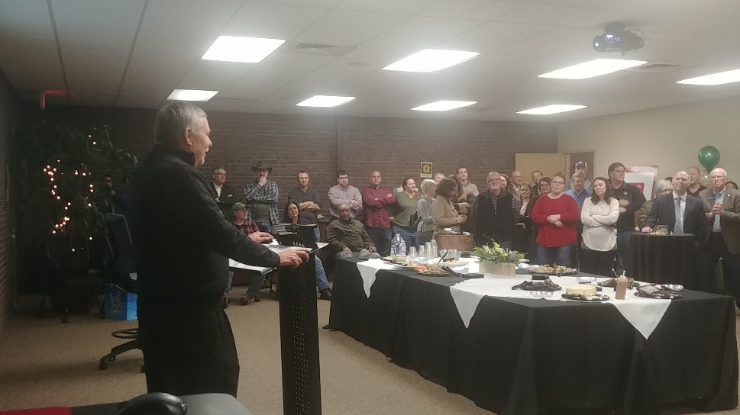Vadakin become the coach in Karma’s senior year. “Believe me when I say this – I let her completely run the women’s team for the year. Hell, if I got in her way, I would have been run over. In fact, in all my years of coaching since then, I’ve never seen anything close to what Karma did for that 1978 team. I have no idea what Karma’s management style is like today, but back then I would describe her as unbelievably **driven**,” said Vadakin. Karma’s team won the national championship again her senior year, making her the only person to be on three national championship bowling teams in the 45-year history of collegiate bowling.

“Karma showed me that no mountain is too high, no goal to big, and that dreams become reality when you pour yourself into what you believe in,” said Vadakin.

*Gary Mason reads a narrative sent by former Wichita State University bowling coach Gordon Vadakin.*

**Local Leadership Highlighted**

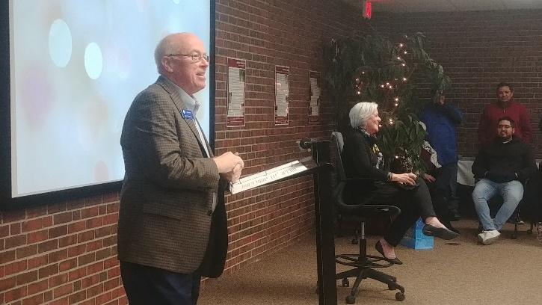Gary Plummer from the Wichita Regional Chamber of Commerce and Alan Cobb from the Kansas Chamber of Commerce and Industry were in attendance and each spoke glowingly about Karma’s leadership, assistance, education, and guidance she had given both organizations. Karma is currently on the board of both organizations and has been involved with each for a number of years.

Tracy Streeter, former director of the Kansas Water Office, expressed similar remarks about Karma from her time on the Kansas Water Authority. She was one of the longest serving women in the board’s history. Streeter praised Karma’s leadership in putting together the state budget for the group. When she presented the budget to legislators, she not only knew the budgetary dollars and cents, but she could speak to all of the technical issues involved as well.

*Wichita Regional Chamber CEO Gary Plummer talks about the impact Karma’s had on the Chamber.*

**Employee Thoughts**

Several employees remarked about their time with Karma both in serious and lighthearted ways. As they’ve done with other retiring or leaving managers, longtime iSi employees Tammy Gonzales and Tami Hadley prepared a [video tribute](https://youtu.be/D4kYop3SBTE). iSi Facility Support Services manager Al Tolbert gave her a U.S. Air Force CMSGT Challenge Coin given only to a few for special achievement and that honor was very special to her as well as a framed photo of her office with “The Birthplace of Leadership” inscribed on it, from iSi’s Dick Genter.

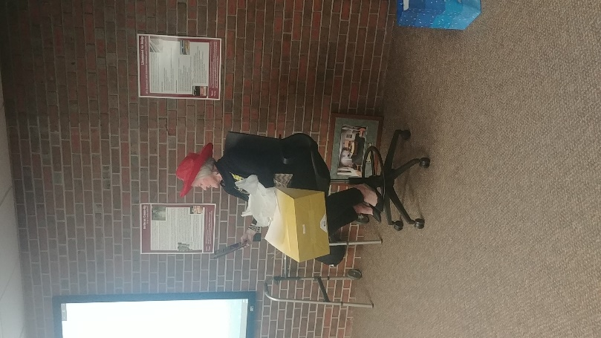Gary Mason said that Karma had been telling many people she didn’t want a rocking chair as a retirement gift, so he said “…we got her something so she could be more active,” – a walker with a bowling ball tied to it. She also received a symbolic key to the building (because she’s always welcome), and gifts to help her decide what to do in retirement such as a red hat, silver sneakers, free crochet lessons, and a book about progressive penny slots. Karma is known for her rock collection, so iSi did give her a serious gift: a heart-shaped geode from Utah.

*Karma goes through her retirement ideas*

*gift and contemplates joining the Red Hat Society.*

*iSi gifted a heart-shaped geode for Karma’s rock collection.*

**Future Plans**

Although she’s no longer going to be at iSi full-time, Karma will remain a part of the company and will continue to provide geological technical assistance when needed.

If you’d like to send well wishes to Karma, [email us here](mailto:feedback@isienvironmental.com) or you can send a card or note to her in care of iSi Environmental, 215 S. Laura, Wichita, Kansas 67211.

A long-time Kansas Chamber member, iSi helps companies manage their environmental and safety risks. iSi has two brands, iSi Environmental, a consulting and facility support services company and iSi Industrial Services, an asbestos and lead abatement firm. iSi Environmental helps companies comply with EPA and OSHA regulations with reports, permits, and sampling, while providing hands-on support through activities such as hazardous waste management, industrial cleaning, and wastewater treatment plant management.



Karma and Gary Mason founded iSi from the dining room table of their home. They started with a computer, a phone, a fax machine, and a checking account containing $700. Gary was a chemical engineer; Karma was a geologist. Many of their friends and colleagues told them they were stupid to leave their steady jobs to set out on their own, but they had a desire for challenging themselves and both had an entrepreneurial spirit that is still strong today.

Today, iSi has over 160 employees and is a regional leader in its fields, working with companies from all across the U.S. iSi has satellite offices in Atlanta, Georgia and Tulsa, Oklahoma.

In 2015, Gary moved on to become Deputy Secretary of the Kansas Department of Health and Environment. Karma remains at iSi as President and CEO and their children are also involved in the business, making it a truly family-owned business.

Karma Mason said, “I’ve had the privilege of working with some truly outstanding employees, clients and people…I am truly blessed.”

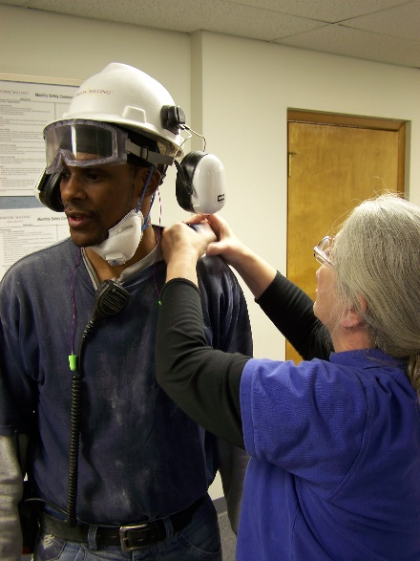

Left: An iSi Environmental industrial hygienist prepares a worker for occupational noise testing

.

Above: iSi Industrial Services project managers survey the preparations for asbestos abatement of a former Wichita Mid-Continent Airport terminal prior to its demolition.



Left: An iSi Environmental environmental scientist conducts stormwater sampling.

Here are a few recent headlines from the world of safety:

**Federal Judge Rules OSHA 300 Info is Not Confidential**

A federal judge in the U.S. District Court for Northern California has ruled that OSHA injury and illness log information is not confidential.  The ruling comes as a part of a lawsuit where news organization the Center for Investigative Reporting made a Freedom of Information Act (FOIA) request to OSHA for records and OSHA denied the claim under FOIA exemptions for "law enforcement" and "trade secrets".

The judge ruled that because employers are required to post this information annually and keep it on file for up to 5 years so that current and former employees can review them, these employees can freely share this information.  Thus, it's readily observable and can be made public anyway.

The Center for Investigative Reporting was pleased with the ruling, saying that it would help keep the "dangerous" employers accountable and encourage them to improve safety while giving workers a better understanding of the risks involved in the job.

**MSA Warns of Shortage of White Tychem, Tyvek**

Personal protective equipment company MSA Safety has issued a notice regarding a shortage of the white DuPont Tychem hoods used for powered air purifying respirators.  DuPont notified MSA that there would be shortages of white Tyvek, including Tychem, materials until early 2021.

MSA will be substituting white hoods with yellow Tychem hoods.  They say that the yellow Tychem is just as protective as the white.  However, some companies have policies requiring the white, and those policies may need to be altered for a while until the supply is restored.

**Respirator Posters Available in 16 Languages**

OSHA's poster "Seven Steps to Correctly Wear a Respirator at Work" has now been published in 16 different languages.  These include English, Spanish, Arabic, Brazilian Portuguese, Chinese (Simplified and Traditional), French Creole, Hmong, Korean, Kunama, Polish, Russian, Somali, Tagalog, Thai and Vietnamese.

As many manufacturing safety managers know, most OSHA documents and posters are not printed in this many varieties, so this is a great time to get these for your workplace.  Find all of these for download at <https://www.osha.gov/news/newsreleases/national/06152020-0>.

**What is an ISO 14001 Environmental Management System?**

The International Organization for Standardization, or ISO, determines internationally agreed upon standards for businesses. ISO standards that end in “001” are management systems. ISO 14001 is for environmental management systems as ISO 9001 is the standard for quality management systems and [45001 is for safety and health management systems](https://isienvironmental.com/index.php/iso-45001-blog/).

Standards in the “ISO 14000 family” relate to environmental management. There are actually other standards in the 14000 family such as 14004, 14006 and 14064-1 that complement ISO 14001 or take it a step further.

**Who Is Required to Have ISO 14001 Certifications?**

**ISO 14001 is voluntary; however, many national and international companies are increasingly requiring their suppliers to become certified.**

Having the certification signals that your company conforms to pre-approved standards of environmental performance and has procedures in place for compliance and improvement. It also shows your company is committed to certain environmental objectives like waste minimization, pollution prevention and climate change mitigation as well as has perspective on the effects of life cycle and the value chain of a product/service.

**What’s the Process for Creating an Environmental Management System?**

**An ISO 14001 environmental management system (EMS) is all about developing and documenting objectives and processes, implementing them, monitoring and measuring their success, reporting results, maintaining them, then taking actions to continuously improve upon them.**

Some of the elements of the EMS include developing procedures for:

* Scope of the EMS
* Leadership and commitment;
* Defining and documenting your environmental policy;
* Organizational roles and responsibilities;
* Identifying risks, threats and opportunities
* Identifying environmental aspects and impacts;
* Establishing environmental objectives and plan for achieving them;
* Resources;
* Competence, training records, skills, experience and qualifications;
* Internal and external communication;
* Document control;
* Operational control;
* Emergency preparedness and response;
* Compliance obligations and evaluation;
* Monitoring and measuring results;
* Internal auditing the EMS and the results from this;
* Management review results;
* Nonconformity and corrective action; and,
* Continual improvement.

**How Do You Become Certified?**

Once you have your procedures developed, you will need to conduct an internal audit of the procedures. From here, tweaks are made and deficiencies are corrected. An external audit is next, that is, a third-party auditor such as iSi will review your system to verify it complies with the requirements. After the external audit, corrections are made before an ISO certification agency does the final certification audit.

**ISO 14001:2015**

The most current version of ISO 14001 is 14001:2015. Any company with the original 2004 certification had until September 15, 2018 to upgrade to the newest version. Thus, the 2004 version is now out of date.

As with newer ISO standards such as [safety standard 45001](https://isienvironmental.com/index.php/iso-45001-blog/), the 2015 revision increases emphasis on commitment from company leadership. ISO is required to be more prominent in an organization’s strategic direction and stakeholder-focused communication is important. Other revisions require proactive initiatives for protecting the environment from harm and degradation and requires companies to consider life cycle, that is, how the entire process from development to end-of-life can affect the environment.

**Benefits of an EMS**

**Even if you are not required to have ISO 14001 certification, developing an environmental management system can be beneficial to your company. Having procedures in place can help improve your overall environmental compliance**. It can help give your company personnel a roadmap of how to manage environmental issues, which can be helpful in times of employee turnover. An EMS will help ensure systems are continuously improved and evaluated. In addition, there may be additional cost benefits through pollution prevention, increased efficiencies, consistency, better resource management, and good public relations.